AZURE TERRAFORM

**Aim**: - Create Virtual network (Vnet) on azure portal by using the terraform.

# **Create Virtual network (Vnet) on azure portal by using the terraform.**

**Create a Virtual network (Vnet):**

Configure the Virtual network (Vnet) file by using the HCL.

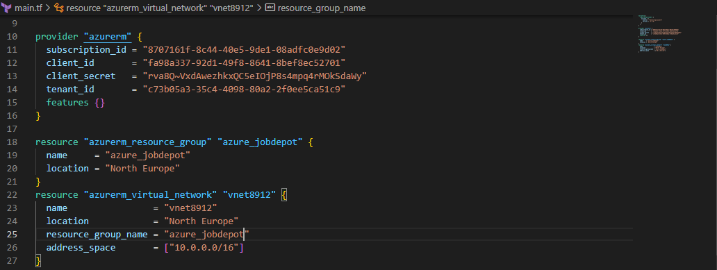

Initialize the terraform configuration file using the following command:

>terraform init

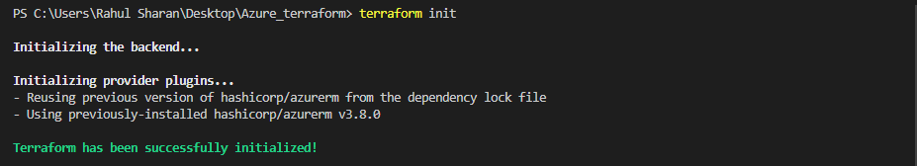

To create an execution plan for Virtual network (Vnet) by using the following command:

>terraform plan –out main.tfplan

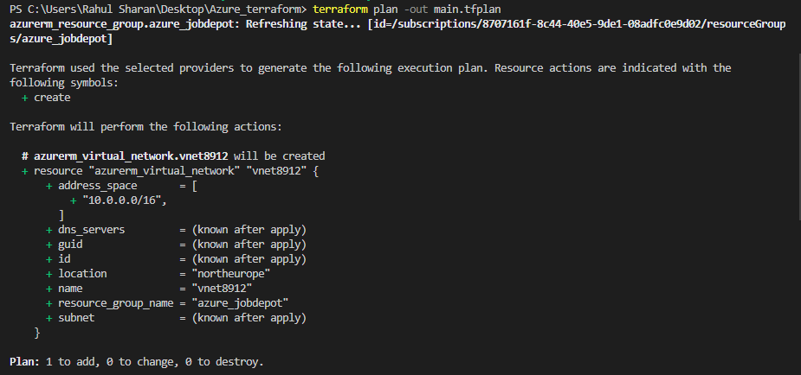

To execute the Virtual network (Vnet) by using the following command:

>terraform apply

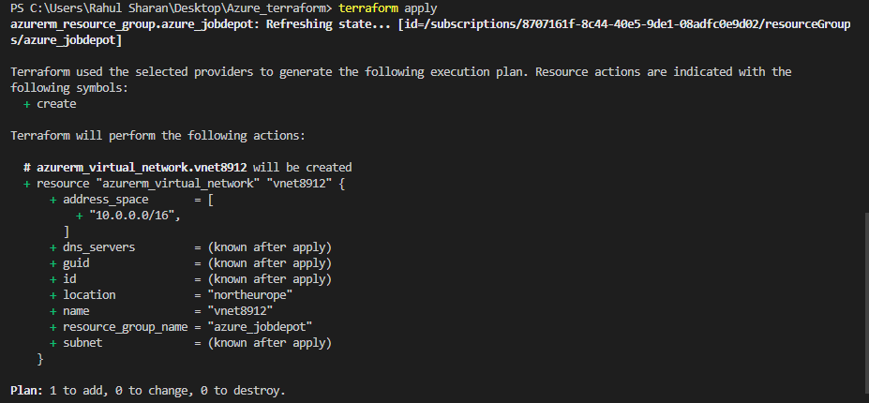

To verify the Virtual network (Vnet) in azure portal:

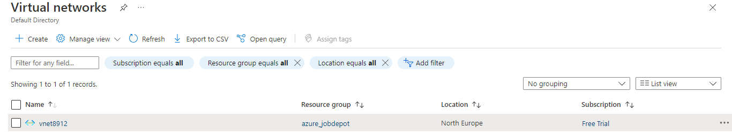

**Create a Virtual Network with two Subnets:**

Configure the Subnet file by using the HCL.

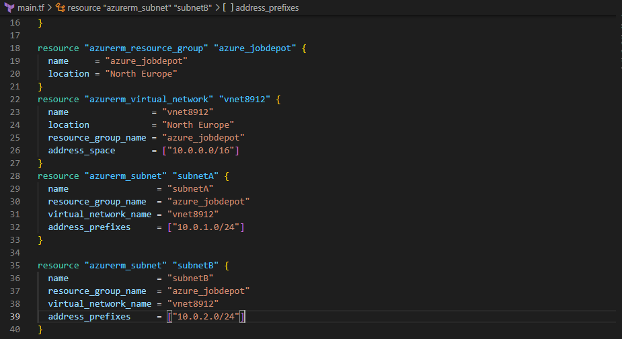

Initialize the terraform configuration file using the following command:

>terraform init

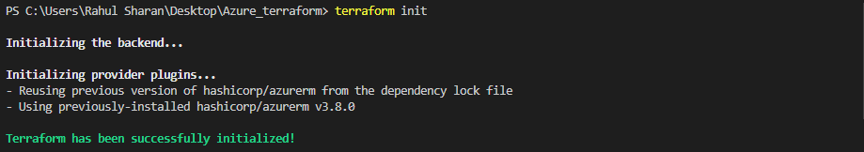

To create an execution plan for Subnets by using the following command:

>terraform plan –out main.tfplan

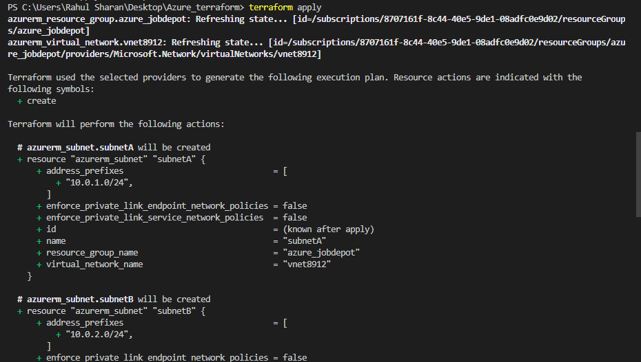

To execute the Subnets by using the following command:

>terraform apply

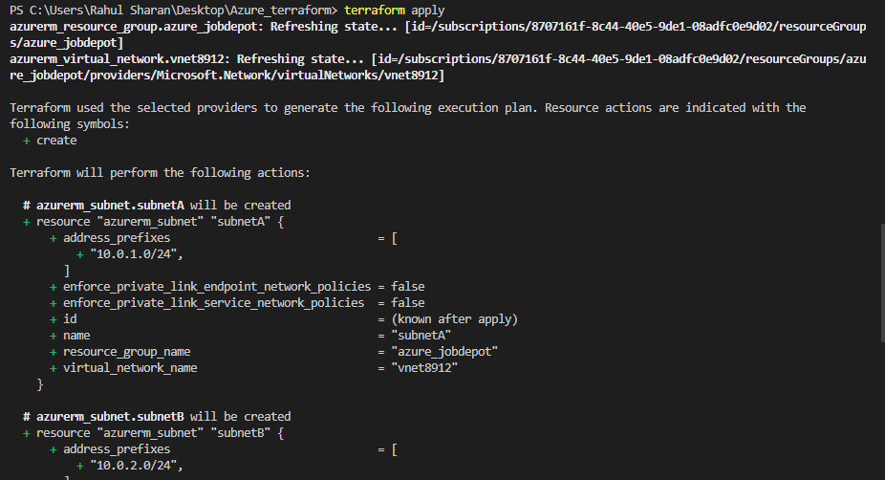

To verify the Subnets in azure portal:

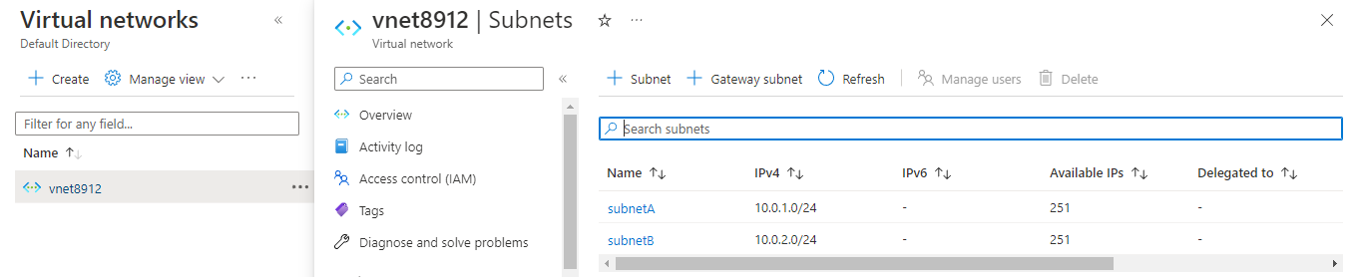

**Create Network interface card (NIC):**

Configure the Network interface file by using the HCL.

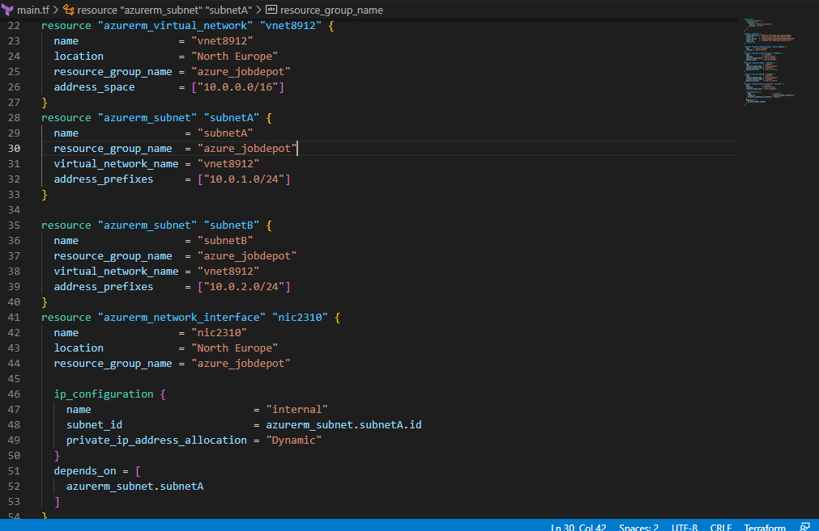

Initialize the terraform configuration file using the following command:

>terraform init

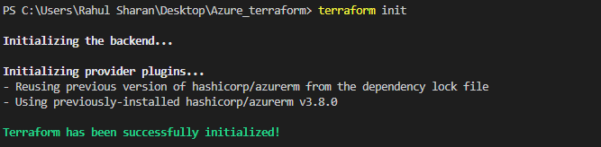

To create an execution plan for Network interface by using the following command:

>terraform plan –out main.tfplan

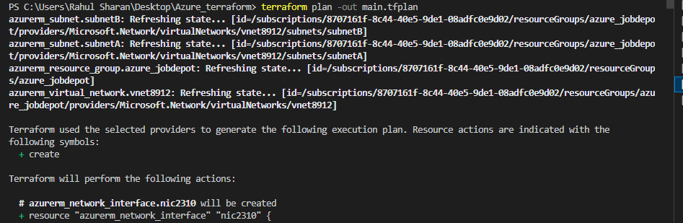

To execute the Network interface by using the following command:

>terraform apply

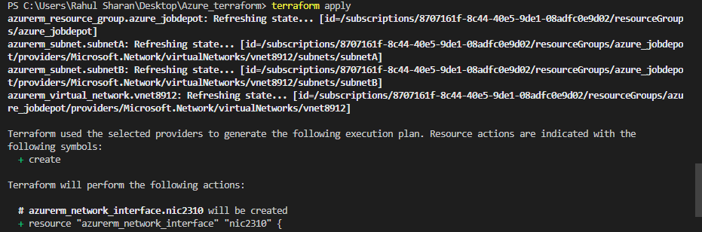

To verify the Network interface in azure portal:

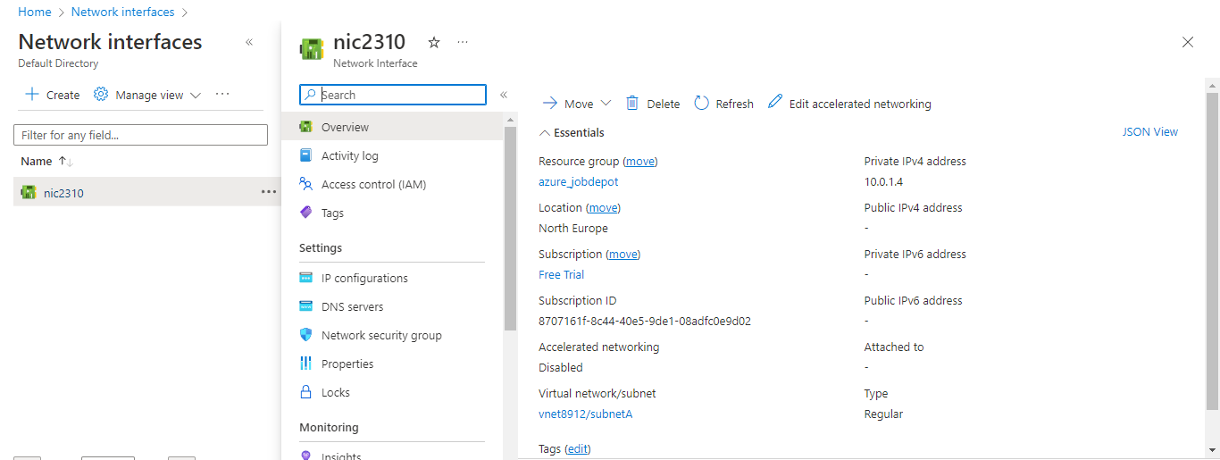

**Create a Public IP:**

Configure the Public IP file by using the HCL.

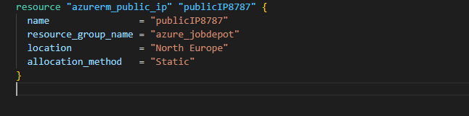

Initialize the terraform configuration file using the following command:

>terraform init

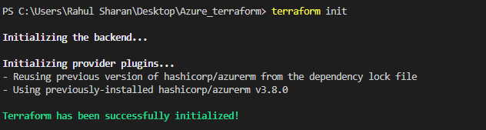

To create an execution plan for Public IP by using the following command:

>terraform plan –out main.tfplan

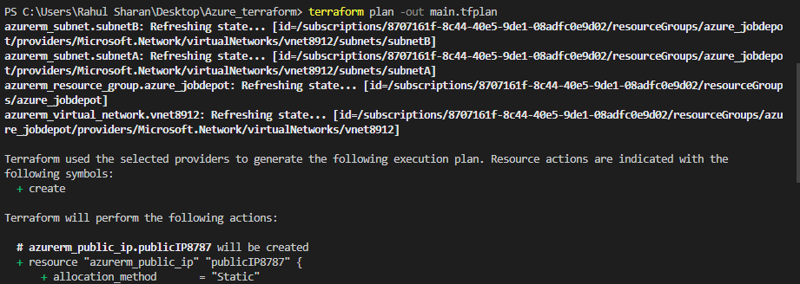

To execute the Public IP by using the following command:

>terraform apply

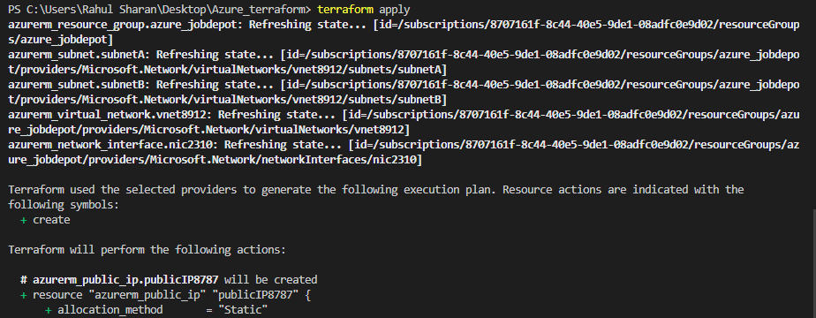

To verify the Public IP in azure portal:

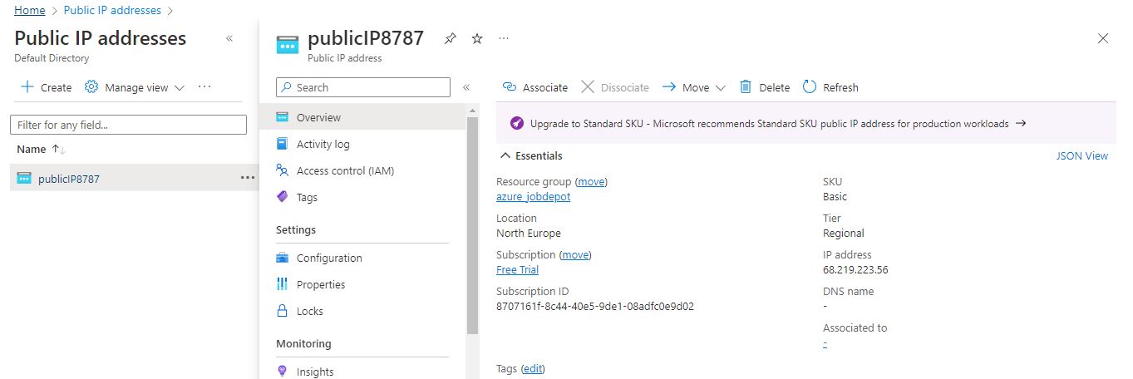

**Create a Network security group by using the local and type value**

Configure the Network security group file by using the HCL.

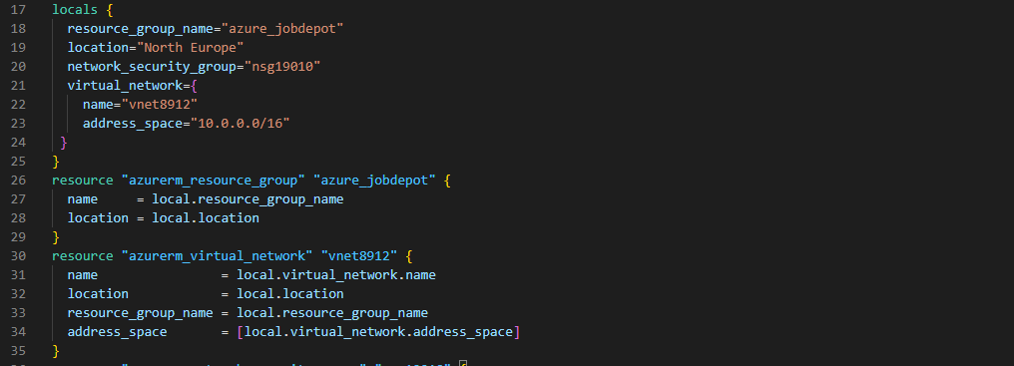

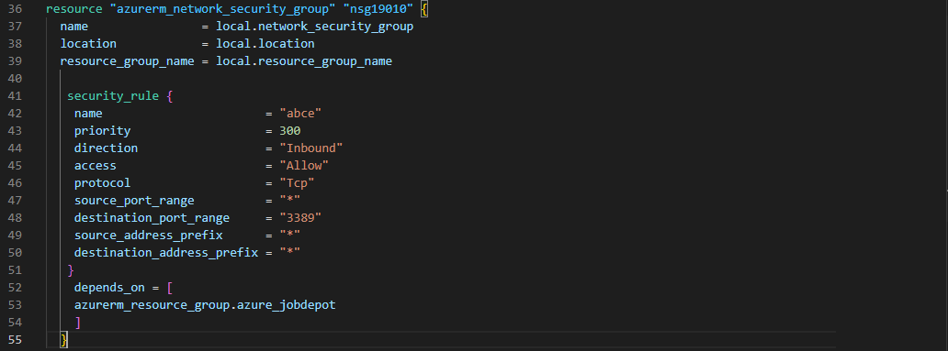

Initialize the terraform configuration file using the following command:

>terraform init

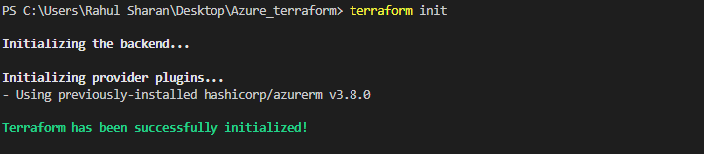

To create an execution plan for Network security group by using the following command:

>terraform plan –out main.tfplan

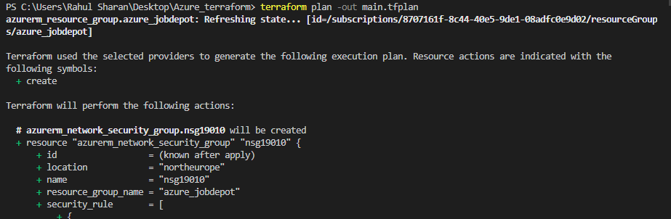

To execute the Network security group by using the following command:

>terraform apply

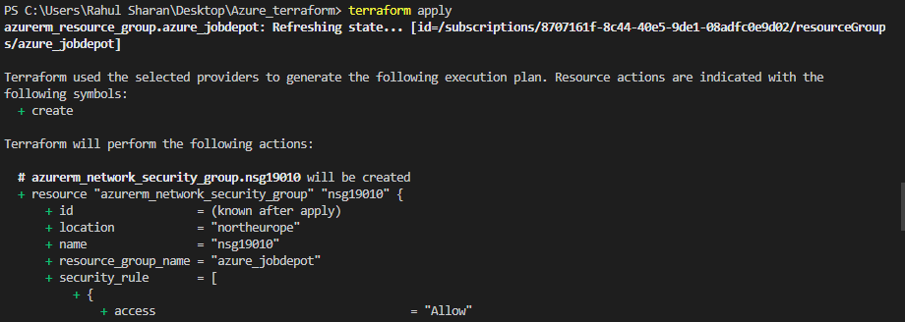

To verify the Network security group in azure portal:

